TRS-80 Model 1(Tandy公司1977年推出)。估计销量：成千上万；原始售价：599美元；当前市场价值：25到250美元

在1977年，Commodore PET 2001、Apple II和TRS-80 Model 1被评为当时电脑领域的三剑客。

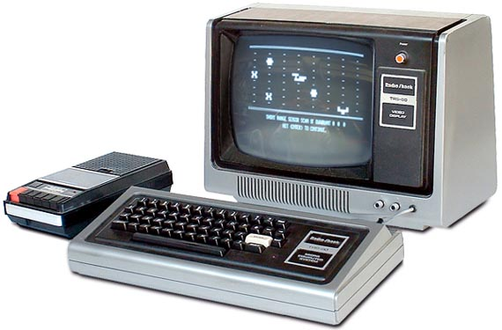

　　当初TRS-80是被摆在Tandy公司旗下的Radio Shack连锁店中出售，所以它也许是美国消费者能在本地购物中心内遇到的第一台电脑，它的外形丑陋菱角分明，但却出奇的实用，在它身后又跟出一大批附加元件以及衍生产品，而其继任者又让Radio Shack一时间成为名副其实的全球知名电脑零售商。虽然现在的TRS-80卖不了多少钱，但若你兼有怀旧情结与囊中羞涩两种情形，去Ira Goldklang所办的“复活TRS-80”(<http://www.trs-80.com/>)这个奇妙站点做一番体验会是不错的选择。

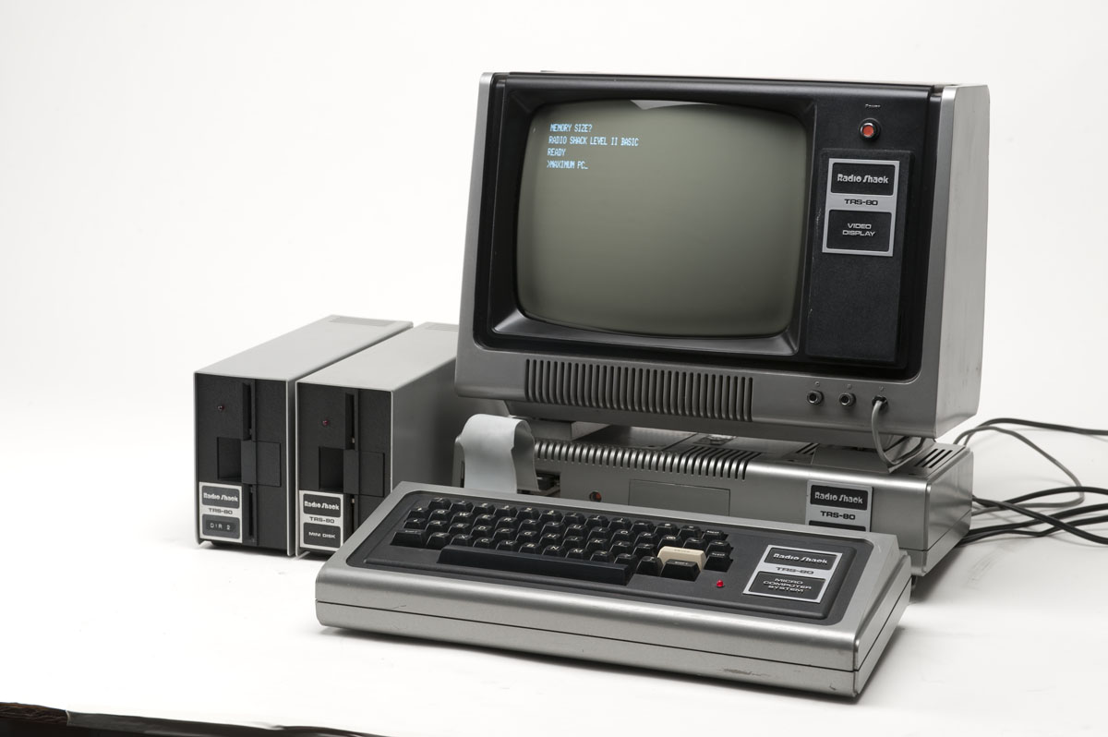

TRS-80    
Type Home computer   
Release date August 3, 1977[1]   
Discontinued January, 1981   
CPU Zilog Z80 @ 1.78 MHz   
Memory 4 KiB ~ 48 KiB

|  |  |  |  |  |  |  |  |  |  |  |  |  |  |  |  |  |  |  |  |  |  |  |  |  |  |  |  |  |  |  |  |  |  |  |  |  |  |  |  |  |  |
| --- | --- | --- | --- | --- | --- | --- | --- | --- | --- | --- | --- | --- | --- | --- | --- | --- | --- | --- | --- | --- | --- | --- | --- | --- | --- | --- | --- | --- | --- | --- | --- | --- | --- | --- | --- | --- | --- | --- | --- | --- | --- |
| |  |  |  | | --- | --- | --- | | http://www.techcn.com.cn/uploads/200912/1261835507EiEn2Vah.gif | http://www.techcn.com.cn/uploads/200912/1261835507U1YwVEhN.gif | http://www.techcn.com.cn/uploads/200912/1261835507tAq6PW51.gif |  |  |  | | --- | --- | | **NAME** | TRS 80 MODEL I | | **MANUFACTURER** | Tandy Radio Shack | | **TYPE** | Home Computer | | **ORIGIN** | U.S.A. | | **YEAR** | 1977 | | **BUILT IN LANGUAGE** | Basic Level 1 (4k ROM models) Basic Level II (12k ROM models) | | **KEYBOARD** | Full-stroke keyboard, 53 Keys, optional numeric keypad | | **CPU** | Zilog Z80 | | **SPEED** | 1.77 MHz | | **RAM** | 4 kb / 16 kb depending on models (up to 48 kb) | | **VRAM** | 1 kb | | **ROM** | 4 kb (Basic Level 1) or 12kb (Basic Level 2) | | **TEXT MODES** | 32 x 16, 64 x 16 | | **GRAPHIC MODES** | 128 x 48 | | **COLORS** | monochrome | | **SOUND** | None | | **I/O PORTS** | Monitor, cassette interface, expansion port | | **OS** | TRS DOS - NEW DOS | | **PRICE** | #26-1003 : Model I, Level I, 16K = 700 http://www.techcn.com.cn/uploads/200912/1261835507xwiUoOle.gif(France,81) #26-1004 : Model I, Level II, 4K = 640 http://www.techcn.com.cn/uploads/200912/1261835507xwiUoOle.gifr (France,81) #26-1006 : Model I, Level II, 16K = $1099 | |

特点

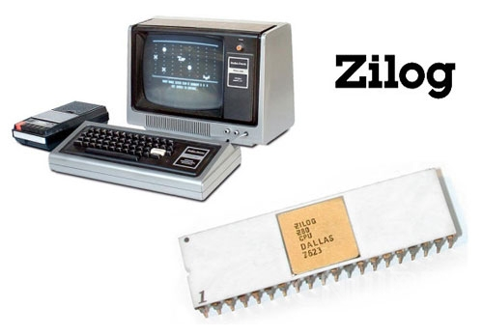

Tandy旗下的TRS-80 Model I被认为史上经典的电脑，虽然缺乏Apple II的潇洒感，但它却是第一款被大多数消费者接受的电脑。据数据统计，有超过20万台这种单色小型机器被Radio Shack售出，这样一个惊人的数量，让它榜上有名也毫无悬念。

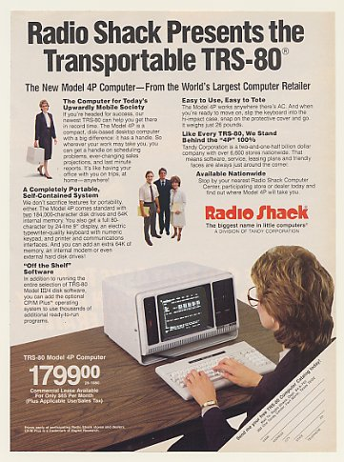

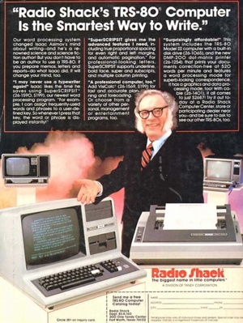

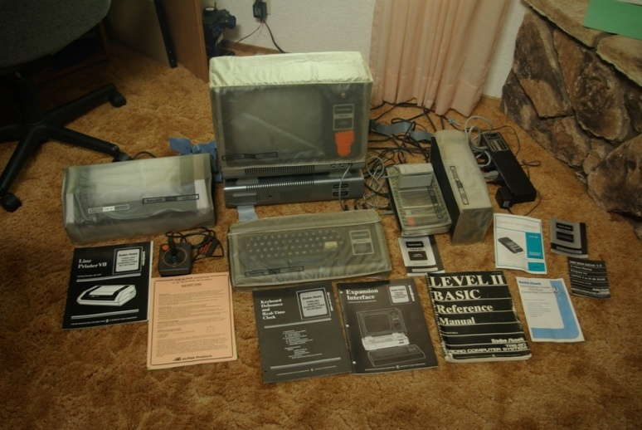

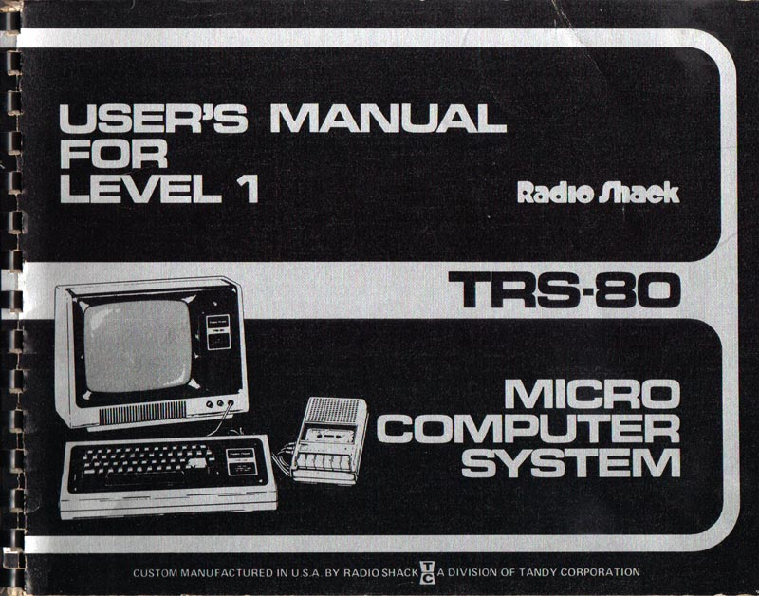

参考文献

<http://en.wikipedia.org/wiki/TRS-80>